**INDUSTRIAL INTERNSHIP PROGRAME**

**REPORT**



Report work submitted in part fulfillment of the requirements for the degree of

**BACHELOR OF TECHNOLOGY (FOOD TECHNOLOGY) in**

**Agricultural Engineering College and Research Institute, Tamil Nadu Agricultural University, Coimbatore.**

For the course:

**FPE 405 INDUSTRIAL INTERNSHIP PROGRAME**

**(STUDENTS READY)**

**By:**

**Arjun Harish BK**

**2019016003 Pavithra G**

**2019016033**

**Department Of Food Process Engineering**

**Agricultural Engineering College and Research Institute**

**Tamil Nadu Agricultural University,**

**Coimbatore – 641003**

**2022**

**CERTIFICATE**

This is to certify that the report entitled **“INDUSTRIAL INTERNSHIP PROGRAME”** submittedinpart fulfilment of the requirements for the award of the degree of **BACHELOR OF TECHNOLOGY (FOOD TECHNOLOGY)** to the **TAMILNADU AGRICULTURAL UNIVERSITY,** **COIMBATORE**, is a record of bonafide research work carried out by **ARJUN HARISH BK ,** **PAVITHRA G** under my supervision and guidance and that no part of the report has been submitted for the award of any other degree, diploma, fellowship, or similar titles or prizes and that the work has not been in part or full in any scientific or popular journal or magazine.

**PLACE:** COIMBATORE. **DATE:**

**INTERNAL EXAMINER**  **EXTERNAL EXAMINER**

**ACKNOWLEDGEMENT**

First of all, I respect & thank **Dr. M. Balakrishnan**, **Professor and Head**, Department of

Food Process Engineering, Agricultural Engineering College and Research Institute, Tamil Nadu Agricultural University, Coimbatore, for giving this opportunity to carry out the internship programme with all support and guidance.

I am also thankful to **Dr. P. Sudha**, **Asst. Professor** and **Dr.S.Parveen , Asst.Professor** Department of Food Process Engineering, Agricultural Engineering College and Research Institute, Tamil Nadu Agricultural University, for providing such a wonderful opportunity to gain a good exposure by organizing and coordinating the internship program as a part of the academic curriculum.

I wish to express my sincere gratitude to Mr. T. Sathish Kumar, Managing Director of Milky Mist Dairy Foods Pvt. Ltd., Erode, for the facilities provided during the course of internship.

I am using this opportunity to express gratitude and special thanks to the GM(Operations) – Mr. Jagannath, Production Manager- Mr. Anburaj and all our individual heads who in spite of being extraordinarily busy with their duties, took time out to listen to the guide and keep me on the correct path and allow me to fulfill my internship with great knowledge.

I would like to extend my gratitude to Mr. Gokul Raj, HR, Milky Mist Dairy Food Private Limited, for this opportunity and for his constant support, encouragement and supervision.

I would also like to thank and convey my deep sense of gratitude to Ms. Vinu to all the Section Heads, Operators and all the workers who helped us in every manner to acquire knowledge and skills.

# 

# 

**CONTENTS**

|  |  |
| --- | --- |
| **S. NO** | **TITLE** |
| 1 | Introduction |
| 2 | Company profile |
| 3 | Milk reception |
| 4 | Quality assurance department |
| 5 | Liquid Milk Processing |
| 6 | Paneer section |
| 7 | Curd section |
| 8 | Yogurt section |
| 9 | Shrikhand section |
| 10 | Butter section |
| 11 | Ghee section |
| 12 | Mozzarella cheese |
| 13 | Cheddar cheese |
| 14 | Processed cheese |
| 15 | Powder plant |
| 16 | Khova section |
| 17 | Gulab jamun mix |
| 18 | UHT & Ice cream |
| 19 | Weekly Report |
| 19 | Conclusion |

## INTRODUCTION

Milky Mist Dairy Food Private Limited (MMD), one of India’s largest manufacturers of dairy products, is located at Perundurai, 20 km (12 mi) from the Erode district in Tamil Nadu. Formed in 1997 by T. Sathish Kumar, Milky Mist is engaged in milk procurement, processing, and manufacturing of other dairy products.

**MILKY MIST**

* + Type - Private company
  + Founded - 1997
  + Founder - **T. Sathish Kumar (MD)**
  + Website - [www.milkymist.com](http://www.milkymist.com/)

**HISTORY**

Initially, MMD’s Plant was set up in just 2 acres of land in Chithode, Erode Dist. In theYear 2019–20, Milky Mist shifted its manufacturing facility from the old plant to a Sprawling, state-of-the-art Mega Plant spread over 55 acres (22 ha) and surrounded by green space. The new plant has a processing capacity of one million litres per day(MLPD) expandable to 1.5 MLPD. It is furnished with the latest technology to Manufacture dairy products like curd, yogurt, mozzarella cheese, and paneer.The Mega Plant has also got various value-added product sections like ghee, butter,Cheddar cheese, cream cheese, shrikhand, and lassi. It has a state-of-the-art spray dryer for converting liquid whey into VADPs.

**GROWTH**

The company has been setting up India’s largest single-location cheese making unit in Perundurai in the Erode district, about 430 km west of Chennai, with an investment of ₹450 crore.The company offers more than 20 products today, including paneer, cheese, ghee, cream and payasam, as opposed to the only three products sold in 2010.

**SUB BRANDS**

* + **Smart Chef –** Frozen Pizza
  + **Briyas –** Tofu paneer
  + **Asal –** Ready to Cook Chapatis and Parottas, Idly Dosa Batter
  + **Capella** – Chocolate
  + **Mistylite** – Fat Spread

**COMPANY PROFILE**

### Products

* + - Fresh Paneer
    - UHT cream
    - Mozzarella cheese
    - Butter
    - Cheddar cheese
    - Ghee
    - Dairy Whitener
    - Skimmed milk powder
    - Dairy permeate powder
    - Ice cream
    - UHT milk
    - UHT lassi
    - UHT milkshake
    - Cream cheese
    - Frozen Paneer Cubes
    - Shrikhand
    - Processed cheese
    - Khova
    - Kalakand (Milk cake)
    - Cheese Spread
    - Curd
    - Probiotic curd
    - Frozen pizza
    - Yoghurt
    - Mishit Doi
    - Gulab Jamun Mix
    - Chocolate
    - Condensed milk

## MILK RECEPTION

Milk is collected directly from farmers without any middlemen intervention, by approximately 25 chilling centres and transported to Milky Mist Dairy in insulated tankers that are kept at a temperature of 4-5°C. When the tankers arrive at the reception dock, the milk is completely mixed with a Plunger in order to distribute the fat particles that float at the top of the milk. The Reception lab receives a sample from the milk tanker for analysis.

### Process of milk after reception

1. Weighing or Measuring
2. Testing
3. Unloading or emptying of tanker
4. Sampling of raw milk

### RMST (Raw Milk Storage Tank)

1) We can use 4 silos for storing 1,00,000 litres of Raw Milk.

2) Raw Milk is Stored at 4℃

**Activities in milk reception**

**Milk Reception**

* Unloading of tankers
* Cleaning of tankers

**Milk Testing**

Milk samples are analysed by,

* Organoleptic
* Physical(colour)
* Chemical parameters.

**Flow from RMRD to RMST**

Fresh milk in tanker

↓

Sampling of milk from tanker

↓

Testing of sample

↓

Inline filter

↓

Deaerator

↓

Pump

↓

PHE for chilling

↓

Raw milk storage tank

**Organoleptic test**

1) Check color, taste & flavor of milk

### Temperature test

1. The temperature is checked by thermometer.
2. The milk is maintained below 4℃

### Methylene Blue Reduction test (MBRT)

1. Take 10 ml milk in the test tube.
2. Then add 1ml methylene blue solution in the test tube.
3. Closed with a stopper and shake well.
4. The test tube was kept in a water bath for 37℃.

### MBRT specification

|  |  |
| --- | --- |
| **Variant** | **Good** |
| **Raw milk** | **>2 hours** |
| **Process milk** | **>8 hours** |

### Acidity Test

1. Take 10 ml of milk in a 100 ml beaker.
2. Add 3 drops of phenolphthalein indicator.
3. Take 10 ml NAOH solution fill into the burette.
4. Titrate with 0.1N NaOH fill faint pinkish color appears.
5. Note the value and calculate following formula,

**Burette Reading X 0.09   
 Acidity = ______________________**

**Volume of Milk X 100**

**Result:**

Acidity=0.144 to 0.150 is acceptable.

**Fat test or Gerber’s method**

* + 1. Take 10 ml 90% Sulphuric acid in butyrometer.
    2. Then add 10.75 ml of milk in butyrometer.
    3. Add 1 ml of Iso-Amyl alcohol in butyrometer.
    4. Closed with cork and shake well.
    5. Kept in to Gerber centrifuge in for 5 mins.
    6. Fat separates upward of the tube.
    7. Then note the fat value.

**CLR Test (CORRECTED LACTOMETER READING)**

1. This test uses a lactometer.
2. This test should be carried out at 29˚c.
3. The lactometer is placed inside the milk up to the brim of the beaker.
4. The value is noted at the end.

### SNF Test (Solid Not Fat)

SNF calculated with following formula,

SNF = 𝐶𝐿𝑅 + 0.36 + (fat × 0.2)

4

**QUALITY ASSURANCE DEPARTMENT**

Milky Mist's priority is to provide consumers with products of superior quality. A specialised team and highly qualified microbiologists and chemists ensure strict monitoring and quality control at every stage of the production process. The laboratories of Milky Mist Dairy are well-equipped and maintained hygienically.

**Products and their respective tests:**

* 1. **Liquid milk**

● Fat

* + - SNF
    - Acidity
    - Protein test (cheese milk)
  1. **Curd** 
     + Milk fat
     + SNF
     + Curd acidity
     + Ph of curd
     + Protein

* 1. **Paneer** 
     + Milk fat, SNF, acidity
     + Paneer moisture, Paneer fat
     + Paneer fat on dry matter
     + Paneer acidity
  2. **Yogurt** 
     + Milk fat, SNF

● pH, Acidity

1. **Mozzarella cheese** 
   * + Milk fat, SNF, acidity
     + Milk protein, c/f ratio
     + Cheese moisture
     + Cheese fat, pH, salt
     + Baking test

1. **Cheddar cheese** 
   * + Milk fat, SNF, acidity
     + Milk protein, c/f ratio
     + Cheese moisture
     + Cheese fat, pH, salt
2. **Processed cheese** 
   * + Moisture
     + Fat
     + Salt
     + pH
3. **Butter** 
   * + Cream fat
     + Butter fat
     + Acidity
     + Moisture
     + Salt (for table butter)

● Curd particles

1. **Ghee**

● Fat

* + - Moisture
    - Refractive index
    - Free fatty acids

### Raw Material and Packaging Material Lab

Raw materials which are used as inclusions or toppings in various value added products are checked for moisture, brix, pH, salt, TS etc. Basic introduction to RM and PM lab (i.e) regular visit to the store to check the RM and PM received that day and previous day night. Collecting the sample from the store and checking with the specific requirements. If the measurements don't match with COA (Certificate of Analysis) we have to raise complaints and the issue has to be sorted immediately before it reaches the unit for further processing.

### Documentation of RM/PM reports

Material unloading from the store was noted regularly and noted the same in respective records in the lab and tests were done continuously for those packing materials like identification of GSM and Compression strength.

### Various machines in RM/PM lab

1. Box compression tester
2. GSM machine
3. Weighing machine
4. Vernier Caliper
5. Refractometer

**Box compression tester**

The container compression test measures the compressive strength of packages such as boxes. It usually provides a plot of deformation vs compressive force. The test is conducted on empty boxes, with the box closure. The results of the constant rate of compression test can be-

1. The peak load
2. The deformation at peak load
3. The load at a critical deformation (head space, etc.)
4. The ability of a container to protect the contents from compression damage etc.

**GSM Machine**

GSM stands for grams per square meter(g/m^2). It is the weight of the carton if you take a sheet of material which is one meter by one meter square and weight in grams. It is a benchmark specification to meet production manufacturing requirements.

**Weighing balance**

It is to check the weight of cups, jars, carton boxes, and other samples that come from different suppliers and to check with the certificate of analysis (COA) and also with the standard that we have maintained here.

**Vernier Calliper**

This is used to measure the neck diameter of cups and jars and also to measure the mm thickness of films and foils or any other packing material.

**Refractometer**

It is used to measure the sugar content of fruit crushes that is used for yogurt samples.

### Microbiology lab

In the microbiology lab, we do continuous testing for various samples from the section and the microbial counts will be noted.

**SWAB test**

It is the counting of the total number of aerobic bacteria, yeasts and moulds on the surface of the product.

### Air Exposure

### Air plates will be kept in elevated regions for 20 mins to determine the air microbial count.

### Sensory Lab

Everyday product will be sensorily tested and the score card will be given and hedonic scale has to be marked.

**LIQUID MILK PROCESSING (LMP)**

This section is also called the Heart of milk processing unit, where milk is received from reception and it is standardized, pasteurized, separated, chilled and stored. Here milk is handled through SCADA (**Supervisory control and data acquisition),** which is operated by a qualified technical officer. The milk from reception (RMRD) is stored in silos and is pasteurized with plate heat exchanger (PHE), standardized and stored in respective silos.

**Cream pasteurization**

Cream

See(From Separator)

↓

Balance Tank

↓

Feed Pump

↓

Regeneration - 1

Plate Heat Exchanger

↓

Regeneration – 2

Plate Heat Exchanger Cooling Section

↓

Cream Storage Tank (Silo)

**Standardization**

It may be defined as the adjustment of one or more of the milk constituents to a nominated level.

**Objectives**

* To comply with the legal requirements for particular milk/dairy products.
* To provide the consumer with a uniform product.
* To ensure economics in production

**Separation**

Centrifugal separation is the most commonly used method in modern dairies. In this method, milk is fed into the rapidly spinning bowl, at the centre of the discs. Regulating the cream discharge opening (affecting the flow) by adjusting the cream screw, we can maintain the desired fat % in cream. This limited running time of separators leads to the development of a mechanism for automatically separating fat from milk.

**Pasteurization**

In general, the term pasteurization as applied to market milk refers to the process of heating every particle of milk. The phosphatase enzyme is destroyed by this time/temperature combination. The phosphatase test is therefore used to check that milk has been properly pasteurized. The test result must be negative; there must be no detectable phosphatase activity.

**Clean in place (CIP)**

Pre – rinsing

↓

Lye – rinse

↓

Acid rinse

↓

Fresh water rinse

↓

Hot water sterilization

**PANEER SECTION**

### Paneer is a non-aged, non-melting soft cheese made by curdling milk generally with a fruit or vegetable-derived acid, such as lemon juice. Paneer is a heat-acid coagulated milk product obtained by coagulating standardized milk.

### In Milky Mist, food grade coagulant is used for coagulation. Milky Mist Paneer is firm Yet soft, with a cohesive, slightly spongy and velvety texture. It has uniform marble White colour, depicting purity. Articulating arm robots are used for various processes Like fragmenting, dicing, and packaging.The Products are hygienically packed in multi layer thermoforming packaging

#### Processing

Raw milk

Standardizing

Heating

Holding

FDV

Paneer milk silo

Shifted into Basin

Addition of coagulant

Coagulation

Drain the Whey

Levelling the Solids in mold

Pressing

Chilling

Cutting according to sku

Packaging

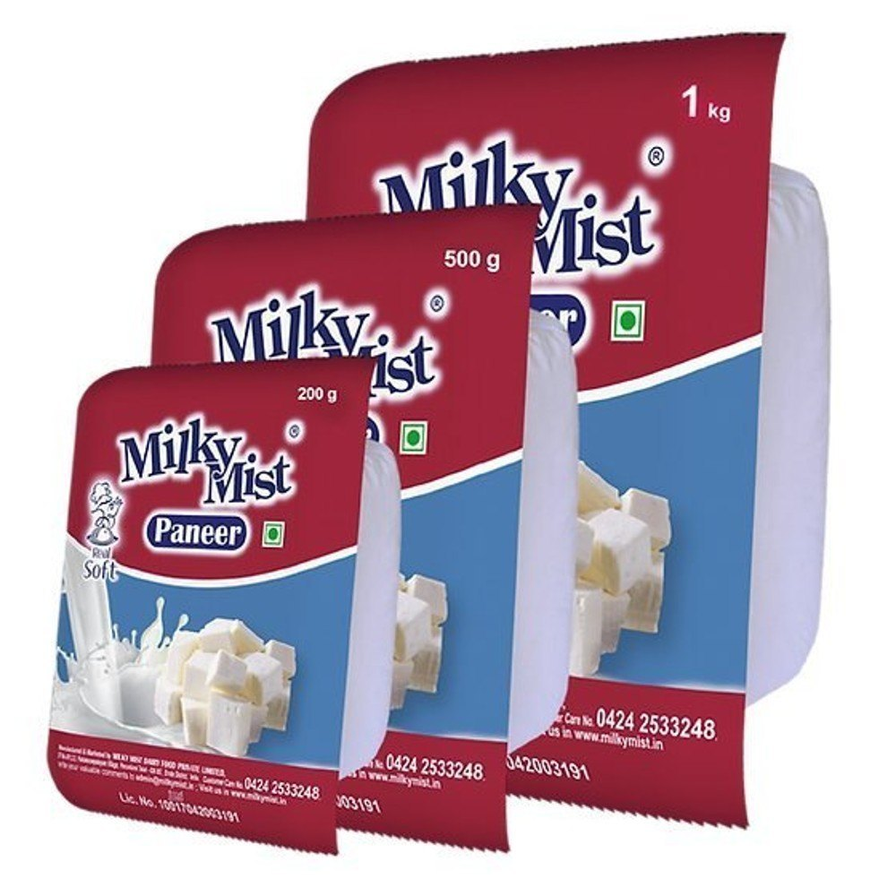

**Figure No:1**

**Frozen paneer cubes**

Paneer blocks after chilling

Cutting into cubes

IQF (Individual Quick Freezer)

Automatic Weighing machine (200gm, 1kg)

Packaging by MAP

Paneer blocks are cut into small cubes of the same size and are sent into IQF, a spiral freezer where the temperature is maintained. The paneer enters the spiral freezer and is frozen when it comes out. Then it is packed by MAP.



**Figure No: 2**

**SKU (STOCK KEEPING UNITS)**

* + **Fresh paneer –** 200g, 500g, 1 kg.
  + **Frozen paneer cubes –** 200g, 500g, 1 kg.

**Shelf life**

* + **Vacuum packed paneer –** 28 days, Cold storage at 4 ° C
  + **Frozen paneer –** 1 year, Frozen storage

### CURD SECTION

### Dahi or curd is a semi solid product, obtained from pasteurized milk by souring, using harmless lactic acid or other bacterial cultures. It is produced from heat treated milks after inoculation with certain species of lactic acid bacteria added to milk in the form of starter culture. Lactic acid bacteria multiply, grow and produce lactic acid, acetic acid and carbon dioxide by utilizing lactose present in milk.

### Yogurt and curd are rich in minerals like calcium, phosphorus, potassium and zinc and also rich in protein. It can help to control 'bad' cholesterol. It is a good source of vitamins like riboflavin, Vitamin B6, Vitamin B12, pantothenic acid and Vitamin A.

#### Types of curd

1. Set Curd
2. Pouch Curd
3. Probiotic curd

#### Curd processing

Raw Milk from Balance Tank

↓

Feed Pump

PHE - 1

↓

Homogenizer

↓

PHE – 2

↓

Holding Tube

↓

PHE – 1

Cooling section

↓

Stored in Silo

↓

Adding Culture

↓

Packaging

↓

Incubation

↓

Blast Room

↓

Stored

**Homogenization**

Homogenization can be defined as the process in which fat globules in milk are broken down into uniform fat globules to prevent the formation of a cream layer. The size of fat globules is reduced to < 1 micron, while normal fat globule size averages 2 – 12µm in milk.

Generally, the size of fat globules ranges from 100-200µm. homogenization is a process to reduce the size of fat globules evenly by applying mechanical force (pressure). Breaking of fat globules takes place in two different phases.

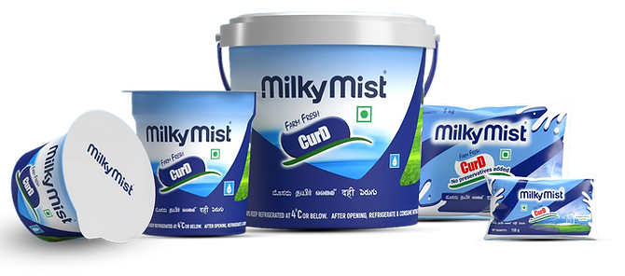

**Figure No: 3**

**SKU (STOCK KEEPING UNITS)**

* + - **Set curd –** 85g, 100g, 200g, 400g; Shelf life – 40 days
    - **Pouch curd –** 200g, 500g, 1kg; Shelf life – 21 days
    - **Probiotic curd –** 200g, 400g, 1kg; Shelf life – 30 days

#### Probiotic curd

Milk and dairy products have been used as the base material for manufacture of the majority of probiotic products as milk has an excellent nutritional value. The culture for probiotic curd differs. all the remaining process remains the same. It consists of many gut friendly microorganisms that improves gut health.



**Figure No: 4**

**Mishti doi**

Milk

↓

Standardization

↓

Pasteurization

↓

Cooled

↓

Addition of starter culture

↓

Packing

↓

Incubation

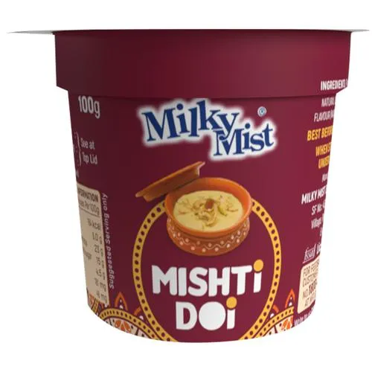

**Figure No:5**

**FRUIT YOGURT SECTION**

Yogurt is the best known of all cultured-milk products, and the most popular almost all over the world. Consumption of yoghurt is highest in countries around the Mediterranean, in Asia and in Central Europe. The consistency, flavour and aroma vary from one country to another. In some areas yoghurt is produced in the form of a highly viscous liquid, whereas in other countries it is in the form of a softer gel. Yoghurt is also produced in frozen form as a dessert, or as a drink.

Yogurt contains energy, protein, carbohydrates, fats, several B complex vitamins especially B2 and B1 in high amounts. Some yogurt may have high folate content depending on the type of lactic acid bacteria like S.thermophilus and Bifidobacteria. Yogurt also contains good amounts of minerals phosphorus and iodine.

**Fruit yogurt processing**

Fresh milk

↓

Chilling

↓

Standardization

↓

Heating

↓

Homogenization

↓

Pasteurization

↓

Cooling

↓

Silo

↓

Preheating

↓

Inoculation tank

↓

Culture addition

**SKU (STOCK KEEPING UNITS) -100g, 1kg**

Milky Mist Fruit Yogurt comes in flavours of Strawberry, Mango, Peach, Guava, Blueberry.

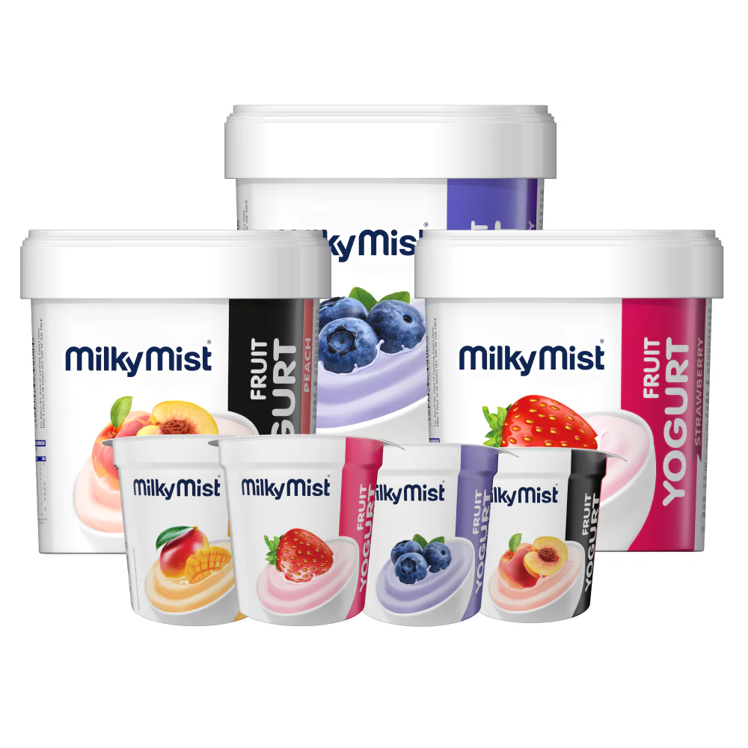

**Figure No:6**

**Bacterial Cultures**

The main (starter) cultures in yogurt are Lactobacillus bulgaricusand Streptococcusthermophilus. The function of the starter cultures is to ferment lactose (milk sugar) to produce lactic acid. The increase in lactic acid decreases pH and causes the milk to clot, or form the soft gel that is characteristic of yogurt. The fermentation of lactose also produces the flavor compounds that are characteristic of yogurt.

### SHRIKHAND SECTION

Shrikhand is a popular fermented, sweetened, indigenous dairy product having semi solid consistency with sweet taste. It is very popular in the state of Gujarat, Maharashtra and part of Karnataka. It is prepared by mixing chakka to form a soft homogenous mass.

**Shrikhand Processing**

Pasteurized milk

↓

Standardization

↓

Addition of starter culture

↓

Incubation

↓

Pressing the chakka

↓

Cooking the chakka in Stephen kettle

↓

Addition of ingredients

While cooking

↓

Filtering

↓

Packing

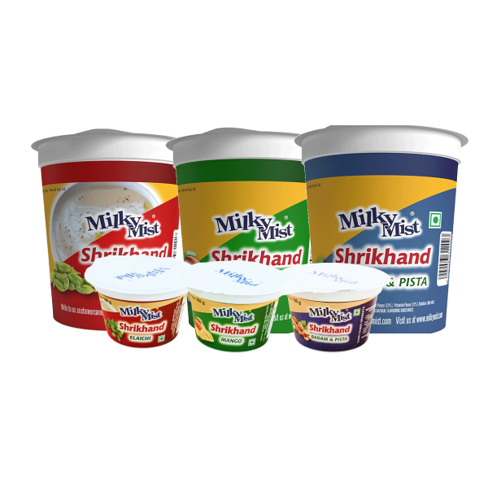

**Figure No:7**

### BUTTER SECTION

Butter is a fat rich dairy product, generally made from cream by churning. It contains a minimum of 80% fat. Butter making is one of the oldest forms of preserving the fat component of milk. Fat is separated from milk in the form of cream using a cream separator.

**Butter process**

Cream

(Separated cream from LMP)

↓

CTA

(Cream Temperature Adjust)

↓

CBMM

(Continuous Butter Making Machine) Churning

Working – 1

Working – 2

↓

Stored in Silo

#### CBMM – Continues Butter Making Machine

Cream

From CTA Process

↓

CBMM

↓

Churning

↓

Separator

↓

Working – 1

(Using Wash water and remove the Buttermilk)

↓

Working – 2

(if table butter salt is added here)

↓

Stored in Butter Silo

**SKU (STOCK KEEPING UNITS)**

Cooking butter – 100g ,200g,500g

Table butter – 100g ,200g,500g

Chiplet butter – Pack of 10, 1 kg.



**Figure No:8**

**Butter Plant CIP System**

CIP for CBMM & silo with packing line in four steps

Melting

↓

Degreasing

↓

Detergent

↓

Rinsing

### GHEE SECTION

Ghee could be in liquid, semisolid and some time in solid state based on the storage temperature. Ghee made from cow milk is golden yellow. Unsalted or white butter is used as raw material.

Butter mass or butter blocks are melted in butter melter. Molten butter is pumped into the ghee boiler where final heating will be done using steam as a heating medium. Increase the steam pressure to raise the temperature. Scum which is forming on the top of the surface of the product is removed from time to time with the help of a perforated ladle.

Moment of disappearance of effervescence, appearance of finer air bubbles on the surface of the fat and browning of the curd particles indicates to stop heating.

At this stage typical ghee aroma is produced. To get the cooked flavor, heating beyond this temperature is also being practiced. Ghee is filtered via oil filter into the settling tank.

Granulation is an important criterion of quality; higher temperature of clarification gives better grain size due to high phospholipids content.

Completely melted ghee on cooling to prevailing Indian temperatures, can assume the form of large, coarse grains suspended discretely or in clusters in a liquid phase. For better granulation, ghee should be slowly cooled and agitation is required during granulation to form smaller granules.

**SKU (STOCK KEEPING UNITS)**

* **Ghee Pet Jar –** 50 ml, 100 ml, 200 ml, 500 ml, 1 lit
* **Ghee Pillow Pouch –** 500 ml, 1 lit
* **Ghee Pouch –** 500ml
* **Ghee sachet**
* **Ghee Tin –** 500 ml, 1 lit, 5 lit, 15 lit

**Ghee processing**

Cow butter

↓

Butter melting vat

↓

Melting of butter

↓

Transfer molten butter to ghee boiler

↓

Boiling

↓

Disappearance of effervescence

Stop cooking

↓

Granulation

↓

Packing

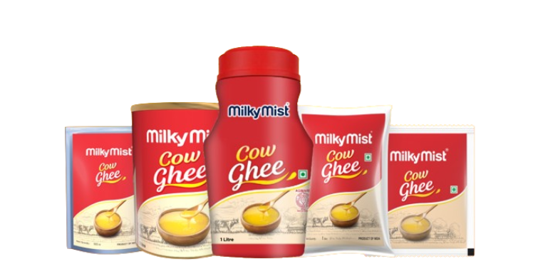

**Figure No:9**

### MOZZARELLA CHEESE

The International Dictionary of Food and Cooking defines this cheese as "a soft spuncurd cheese similar to Mozzarella made from cow's milk" that is used particularly for pizzas and [that] contains somewhat less water than real Mozzarella".

Low-moisture part-skim mozzarella, widely used in the food-service industry, has a low galactose content, per some consumers' preference for cheese on pizza to have low or moderate browning. Some pizza cheeses derived from skim mozzarella variants were designed not to require aging or the use of a starter.

**Section**

* Coagulation vat
* Maturation tunnel
* Stretching & cooking
* Molding
* Brine tank
* Micro filtration

#### Process

Milk is preheated and received in vat. After the complete filling of vat culture and is added. After coagulation the curd is cut in three stages. The curd is cut, and left to sit so the curds firm up in a process known as healing.

After the curd heals, it is further cut. The curds are stirred and heated to separate the curds from the whey. The whey is then drained from the curds and the curds are placed in a hoop to form a solid mass, which is the point when the cheese can be stretched and kneaded to produce a delicate consistency, this is then typically formed into cylinder shapes.

**SKU (STOCK KEEPING UNITS)**

* **Mozzarella pizza cheese blocks –** 200g, 1 kg; Shelf life – 6-9 months
* **Pizza Cheese – Mozzarella Diced –** 200g, 500g, 1kg, 2kg; Shelf life – 1 year
* **Pizza Cheese Mozzarella Shredded –** 200g, 500g, 1kg, 2kg; Shelf life – 1 year Frozen storage.

**Mozzarella cheese processing**

Receiving cheese milk from LMP

↓

Standardization

↓

Pasteurization

↓

Cooling

↓

Preheating

↓

Vat

↓

Addition of starter culture

↓

Addition of rennet

↓

Coagulation(setting) (do not disturb)

↓

Cutting

↓

Cooking

↓

Drainage of whey

↓

Flush cooling water

↓

Maturation tunnel

↓

Transfer in stretching machine

↓

Molding into shapes

↓

Immersion in chilled brine

↓

Drying

↓

Ripening

↓

Packaging

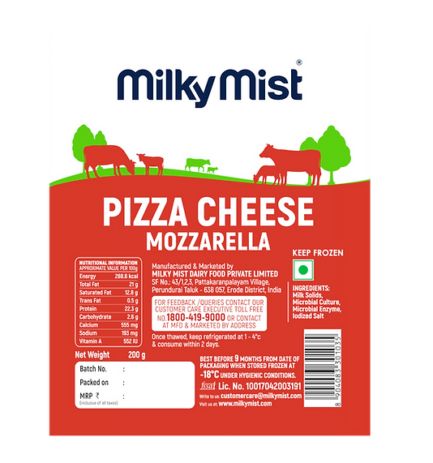

**Figure No:10**

### CHEDDAR CHEESE

Milky Mist Cheddar Cheese, the right vintage perfection for that extra tasty Italian delight. Cheddar cheese is a hard, ripened cheese with a long shelf life and without any surface Flora. It is common in the world due to its distinct taste, aroma and flavor. Cheddar cheese was firstly manufactured in the town of Cheddar; England.

**Cheddar cheese processing**

Receiving milk

↓

Standardization

↓

Filtration / Clarification

↓

Pasteurization

↓

Pre - heating

↓

Vat

↓

Adding Starter Culture

↓

Addition of rennet

↓

Coagulation / Setting

↓

Cutting

↓

Cooking

↓

Stirring

↓

Vat

↓

Drainage of Whey

↓

Cheddaring

↓

Milling

↓

Salting

↓

Hooping

↓

Dressing

↓

Pressing

↓

Drying

↓

Vacuum sealing

↓

Dipping in hot water

↓

Ripening

**Further processing**

It is used for further processing of processed slices or cheese blocks or cheese cubes.

**SKU (STOCK KEEPING UNITS):** 200g, 1kg

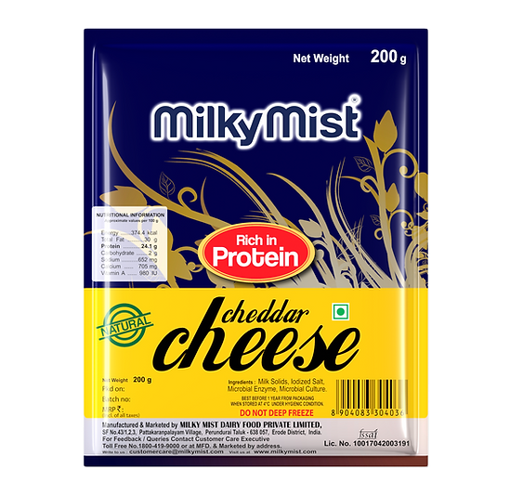

**Figure No:11**

**PROCESSED CHEESE SECTION**

Processed Cheese slices are staple for many families these days, as they can be used for everything from preparing quick sandwiches to topping casseroles and many other dishes, which dramatically changes the taste, craving for more of it.

**Introduction**

Processed cheese is a product made by blending natural cheese of different ages in required proportion with emulsifying salts followed by heating and continuous mixing to form a homogeneous mass. Processed cheese was initially manufactured with the aim of increasing the shelf life of natural cheese.

According to FSSR (2011), Processed Cheese Means the product obtained by grinding, mixing, melting and emulsifying one or more varieties of cheeses with the aid of heat and emulsifying agents. It shall have pleasant taste and smell free from off flavor and rancidity. It may contain food additives permitted in the regulation and it shall conform to the microbiological requirements as prescribed in the regulation. It shall have moisture not more than 47% and milk fat not less than 40% on dry matter basis.

**Methods of Cooking**

* + **Continuous Cooking System (CCS) –** used for making cheese slices
  + **Batch Cooker –** used for making cheese blocks, cubes
  + **Stephen Kettle –** used for making cheese tins

Out of the above three cooking systems, CCS has the highest capacity

**Continuous Cooking System**

Cheddar cheese blocks which are procured for the making of processed cheese are Loaded into grinding machine through conveyors to make it into shreds. These shreds are blended along with other ingredients in the blender. The blended cheese is checked For its moisture and pH. Blended mixture is cooked. Once cooking is completed, the Processed cheese is sent for packaging into slices. The cheese slices are cooled by cold Water immersion. Modified Atmosphere Packaging (MAP) is done for cheese slices.Cheese slices are packed in cartons.

**Batch Cooker**

In batch cooker, production does not happen continuously, happens in batches in Batch cooker. Grinded cheese shreds are loaded into batch cooker and Other ingredients are added. Cooked well and sent for packaging into blocks or cubes. Aluminium foil is used as primary packaging for blocks and cubes since the product is Not immediately cooled like slices, but cooled slow in spiral cooler.

**Stephen Kettle**

Works similar to Batch cooker.

**Types of processed cheese**

* Cheese Block
* Cheese cubes
* Cheese slices

**Manufacturing of processed cheese**

Preparation of process cheese

↓

Selection and Computation of ingredients

↓

Shredding and Mixing

↓

Processing the blend

↓

Hot Packing and Cooling

↓

   Storage

**SKU (STOCK KEEPING UNITS)**

* **Cheese slices –** 100g, 200g, 765g
* **Cheese blocks –** 200g, 500g, 1kg
* **Cheese cubes –** 120g, 200g, 600g
* **Cheese tin –** 400g

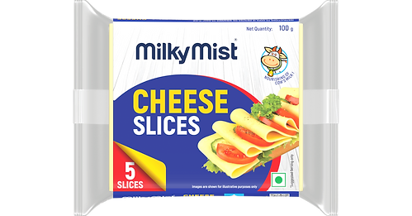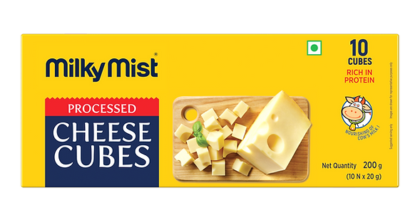

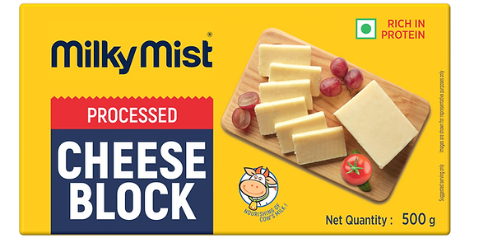

**Figure No:12**

**POWDER PLANT**

This powder plant is mainly used for drying the whey which is obtained during the cheese & Paneer production. In most of the companies the whey is drained. But here, on the view of wasting the milk solids such as whey protein, lactose & milk fat and to avoid that they got an idea to dry the whey which also becomes economical for them.

#### Introduction

Whey is left over when milk is [coagulated](https://en.wikipedia.org/wiki/Coagulation_(milk)) during the process of cheese & Paneer production, and it contains everything that is soluble from milk after the [pH](https://en.wikipedia.org/wiki/PH) is dropped to 5 during the coagulation process.

SMP is the product obtained by the removal of water from milk by heat or other suitable means to produce a solid containing 4 percent or less moisture.

#### Products manufactured

* Dairy Permeate Powder
* SMP (Skimmed Milk Powder)
* Dairy Whitener

**Process involved in Whey Powder**

* Pasteurization
* Nano Filtration (NF)
* Electro Dialysis (ED)
* Evaporation
* Crystallization
* Spray Drying
* Packing

**Pasteurization**

The pasteurizer time temperature combination used is heated up to 73°c and holds for 15 seconds and then chilled to 4°c. The temperature of heating of whey is fixed at 73°c because as we know the minimum temperature for HTST is 72°c and to be hold for 15 seconds and the reason not heating above 73°c is basically the prime component in the whey is the whey protein precaution that the whey protein does not to be get denatured, they are not heating more than 73°c, because the whey proteins stats denaturing at 70°c so that 73°c is fixed.The chilling temperature is fixed at 4°c which is common.

**Demineralized Whey**

Whey water gets demineralised in electro dialysis process when the pH is neutralised.

Different processes have been developed and shall in short be mentioned here:

1.Nanofiltration

2.Electrodialysis

**Nanofiltration**

Nanofiltration is an RO process with relatively open membrane structure allowing in particular small monovalent ions.

**Evaporator**

#### Falling Film Evaporator

In falling film evaporators, Whey and vapor’s flow downwards in parallel flow. The Whey to be concentrated is preheated to boiling temperature. An even thin film enters the heating tubes via a distribution device in the head of the evaporator, flows downward at boiling temperature, and is partially evaporated. This gravity-induced downward movement is increasingly augmented by the co-current vapor flow. Falling film evaporators can be operated with very low temperature differences between the heating media and the boiling liquid.

**Spray dryer**

Drying is a method of food preservation that inhibits the growth of micro-organism like for instance yeasts and mold through the removal of water. Drying is one of the oldest preservation processes available to mankind, one that can be tracked since ancient times. According to Marco Polo’s accounts of his travels in Asia, Mongolians produced milk powder by drying milk in the sun.

Spray drying is a method of producing a dry powder from a liquid or slurry by rapidly drying with a hot gas. This is the preferred method of drying of many thermally-sensitive materials such as foods. A consistent particle size distribution is a reason for spray drying some industrial products such as catalysts. Air is the heated drying medium; however, if the liquid is a flammable solvent such as [ethanol](https://en.wikipedia.org/wiki/Ethanol) or the product is oxygen-sensitive then [nitrogen](https://en.wikipedia.org/wiki/Nitrogen) is used.

#### Powder packing Area

#### Powder is manually packed, with the help of weighing balance. But during packing, the person who is involved in packing must be wearing a head cap, mask, hand gloves, apron etc.

The powder bags are sealed by threading.

**Two layers of packaging**

1. Inner -LDPE Liner
2. Craft bag

#### Powder storage

#### In this storage they can store 1000 tons of powder including both whey powder and SMP.

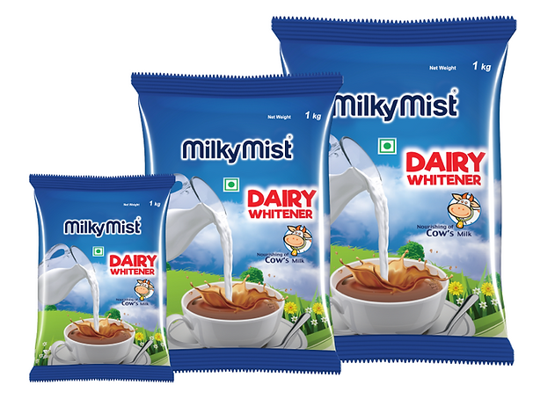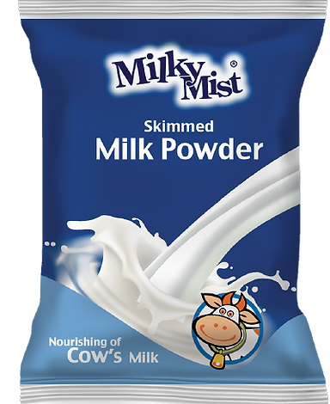

**Figure No:13**

**KHOVA SECTION**

Made from Milk gives you that creamy texture and milky aroma. Widely supplied to all Institutions such as sweet makers, exporters etc, has encouraged us to move on to continue Khova making machineries.

**Khova milk Processing**

RCM (Raw Chilled Milk)

↓

Evaporated

↓

Condensed Milk

**Khova Process**

Condensed Milk

↓

Stored in Silo

↓

Heating and agitation

↓

Khova

↓

Keeping in trays

↓

Packaging

↓ Stored

**SKU (STOCK KEEPING UNITS): 200g, 1kg, 5kg**

* **Unsweetened khova –** Evaporated milk
* **Kalakand –** Raw chilled milk, Sugar
* **Milk cake –** Evaporated milk, Ghee, Sugar

**GULAB JAMUN MIX SECTION**

Gulab jamun is a popular classic Indian sweet made from milk solids. It is very famous & is enjoyed in most festive and celebration meals. It is made from using khova and now it is made from milk powder.

#### Gulab jamun mix processing

Maida

↓

Sieving (To remove dust particles)

↓

Heating

↓

Cooling

↓

Ribbon blender

(Addition of ingredients)

↓

Cooling (overnight)

↓

Packing (200 g)

↓

Storage

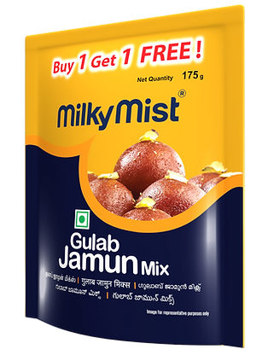 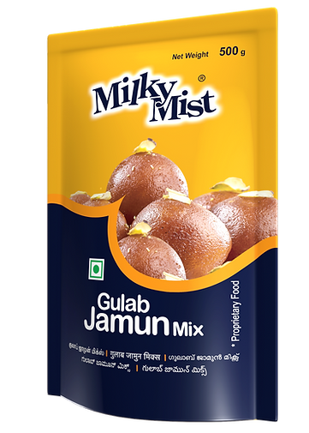

**Figure No:14**

**UHT (ULTRA HIGH TEMPERATURE)**

Milky Mist has brought a complete range of UHT products. These are packed under hygienic conditions & they come with a longer shelf life. The Ultra-High-Temperature (UHT) processing ensures these products remain good for a longer time. UHT products are subjected to very high temperature and are processed & packaged under sterile

conditions.

Milky Mist offers a wide range of UHT products including Toned milk, Double Toned Milk, Skimmed Milk, Lactose Free Milk, Cream, Milkshakes, Lassi and Buttermilk.They can be stored at Room temperature.

**UHT PRODUCTS**

**UHT MILK:**

There are three variants of UHT processed milk: **Toned Milk, Double Toned Milk & Skimmed Milk**

**SKU:** 200ml, 500ml, 1 L; Shelf life – 6 months

**LACTOSE FREE MILK**: 200ml, 500ml, 1 L; Shelf life – 5 months

**UHT CREAM:**

Milky Mist Milk Cream is packed under highly hygienic conditions & it delivers a

consistent and smooth texture to all your dishes. SKU: 200ml, 1 L; Shelf life – 5 months

**UHT BUTTERMILK**: This low-fat beverage is best to keep your health in check. It

comes with an amazing spiced flavour & a longer shelf life. SKU: 200ml

**UHT LASSI:** Variants like Rose, Blueberry & Mango are available. SKU: 200ml

**UHT MILK SHAKES**:

It is the perfect blend of milk protein & fresh nutrients, along with different flavours.

Variants like Vanilla Milkshake, Strawberry Milkshake & Chocolate Milkshake are

available. SKU: 200ml

**Milkshake**

Standardised UHT grade milk

↓

Pasteurisation

↓

Filled in mixing tank

↓

Addition of ingredients & flavouring

↓

Blending

↓

UHT treatment

**UHT TREATMENT**

Product

↓

Balance Tank

↓

Pre-heating & Homogenisation Packing Material

↓ ↓

Deaeration Activation

↓ ↓

Sterilization. Bottom sealing

↓ ↓

Aseptic tank Package Sterilization

Filling

↓

Ultra sealing

↓

Secondary packing and storage

**ICE CREAM**

Ice cream is a dessert made from fresh whole milk, along with other ingredients like Sugar, flavourings etc. Fruit pulp are also added to ice creams to enhance its flavour.

**Flavours**: Vanilla, Chocolate, Strawberry, Butterscotch, Blackcurrant, Tender

Coconut and Mango.Available in different forms - tubs of varied sizes & shapes, cones, party packs etc.

SKU: 60ml, 90ml, 100ml, 125ml, 500ml, 1 L etc.

Standardized whole milk

↓

Addition of ingredients

↓

Pre-heating & Homogenisation Cold storage (<0°C)

↓ ↓

Pasteurisation Hardening Tunnel

↓ ↓

Aging Freezer (Air incorporation)

↓ ↓

Flavour addition Packing

# 